

Requirement & Design Specification
Global Access Management System (GAMS)
Version: 1.0

– Hanoi, August 2022 –

Record of Changes
Version | Date | A*  M, D | In charge | Change Description
V1.0 | 15/2 | A | KienNTHE11
*A - Added M - Modified D - Deleted

Contents
Record of Changes 2
I. Overview 4
1. User Requirements 4
1.1 Actors 4
1.2 Use Cases 4
2. Overall Functionalities 5
2.1 Screens Flow 5
2.2 Screen Descriptions 5
2.3 Screen Authorization 5
2.4 Non-UI Functions 6
3. System High Level Design 6
3.1 Database Design 6
3.2 Code Packages 7
II. Requirement Specifications 8
1. <<Feature Name>> 8
1.1 <<UseCaseCode_UC Name>> 8
2. Common Functions 11
2.1 UC-2_Login System 11
3. Patron Feature 12
3.1 UC-5_Order a Meal 12
3.2 UC-6_Register for Payroll Deduction 13
III. Design Specifications 14
1. <<Feature Name>> 14
1.1 <<SubFeature Name>> 14
1.2 System Access 15
IV. Appendix 19
1. Assumptions & Dependencies 19
2. Limitations & Exclusions 19
3. Business Rules 19
4. .. 19

III. Design Specifications

1. <<Feature Name>>

1.1 <<SubFeature Name>>

a. <<Screen/Function Name>>
[Provide brief description of the screen/function + related UC here and other details as in the sub-sections]

UI Design
[This is to describe the UI layout (Mockup prototype) & descriptions for screen fields/components]
<<Mockup prototype>>
Field Name | Field Type | Description
Field Group Name
<<Field-Name>> | <<Field type>> | <<Field description & data initializing design>>

Database Access
[Provide the design description for the screen/function to access the database here: what table the screen/function would access, which transactions does it make (C-Create, R-Read, U-Update, or D-Delete), and how/purpose of the access (by providing Description and SQL commands)]
Table | CRUD | Description
<<Table Name>> | <<transaction(s)>> | <<Table access description: purpose, how,…>>
..

SQL Commands
[Provide the detailed SQL (select, insert, update...) which are used in implementing the screen/function]

1.2 System Access

a. User Login
This screen allows user to be authenticated to the system screens/functionalities.
Related use cases:
- UC02_Login System

UI Design
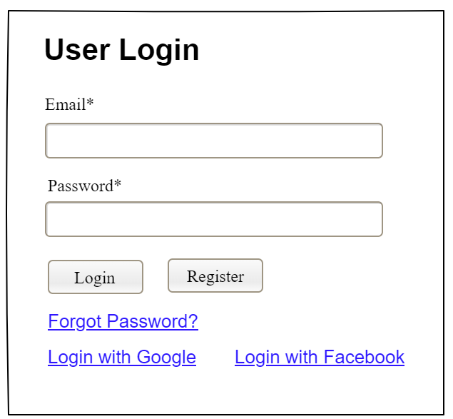

Field Name | Field Type | Description
Email* | Text Box | This is for user to input valid email address for logging in
Password* | Password Box | This is for user to input password for logging in
Login | Button | User clicks to authenticate him/herself into the system with provided email & password
Register | Button | User clicks to redirect to the User Register page for registering new user account to access the system
Forgot Password? | Hyperlink | User clicks to redirect to the Password Reset page for resetting his/her forgot password
Login with Google | Hyperlink | Allow user to login with his/her Google account
Login with Facebook | Hyperlink | Allow user to login with his/her Facebook account

Database Access
Table | CRUD | Description
User | R | Verify UserName & Password information
Setting, User | R | Specify the authorizations of the logged-in user

SQL Commands:
1/ Verify UserName & Password information
SELECT user_id, full_name, email, image_url, status
FROM user WHERE user_name = ? AND password = ?

2/ Specify the authorizations of the logged-in user
SELECT mapped_values FROM setting WHERE setting_id = ?
SELECT setting_name, mapped_values FROM setting WHERE setting_id IN (?)

b. Setting List

UI Design
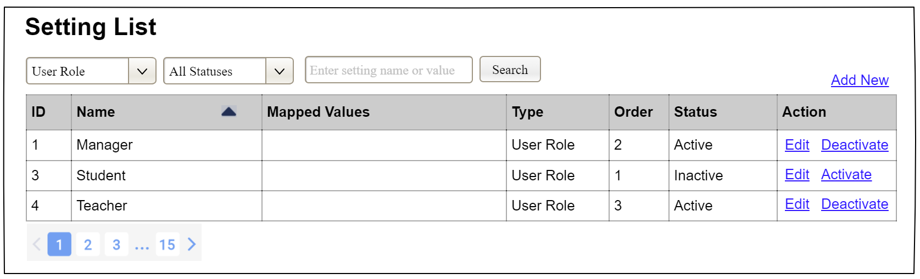

Field Name | Field Type | Description
Search Fields
Setting Type | Combo Box  Single-Choice | Filled with the list of current active setting types  Allow to filter the list by setting type;  Default value is “All Types”
Setting Status | Combo Box  Single-Choice | Values: All Statuses (default), Active, and Inactive  Allow to filter the list by status  Default value: “All Statuses”
Search Phase | Text Box  String (30) | Allow to search using the name or map values  Default value: blank
Search | Button | Click to refresh the list with the defined filter(s) and search phrase.
Add New | Hyperlink | Click to open the Setting Details page for adding new setting (master data)
Data Table
ID | Integer | Auto-increased identifier of the setting
Name | Text | Name of the setting
Mapped Values | Text | Supplementary information for the setting
Type | Text | Type of the setting
Order | Integer | Display order of the setting: the order of the setting type, displayed among the list of settings with the same type
Data Actions
Edit | icon | Click to open the Setting Details page for updating the relevant setting (master data)
Activate | icon | Shown when the data status is inactive. This is to activate the relevant setting (master data)
Deactivate | Ion | Shown when the data status is active. This is to deactivate the relevant setting (master data)

Database Access
Table | CRUD | Description
Setting | RU | Query the list of current settings from the database  Update status of a specific setting

SQL Commands:
1/ Query the list of current settings from the database
SELECT setting_id, setting_name, mapped_values, type_id, display_order, status
FROM setting WHERE (setting_type = ?) AND (status = ?) AND (setting_name LIKE ?)

2/ Update status of a specific setting
UPDATE setting SET status = ? WHERE setting_id = ?

c. Setting Details

UI Design
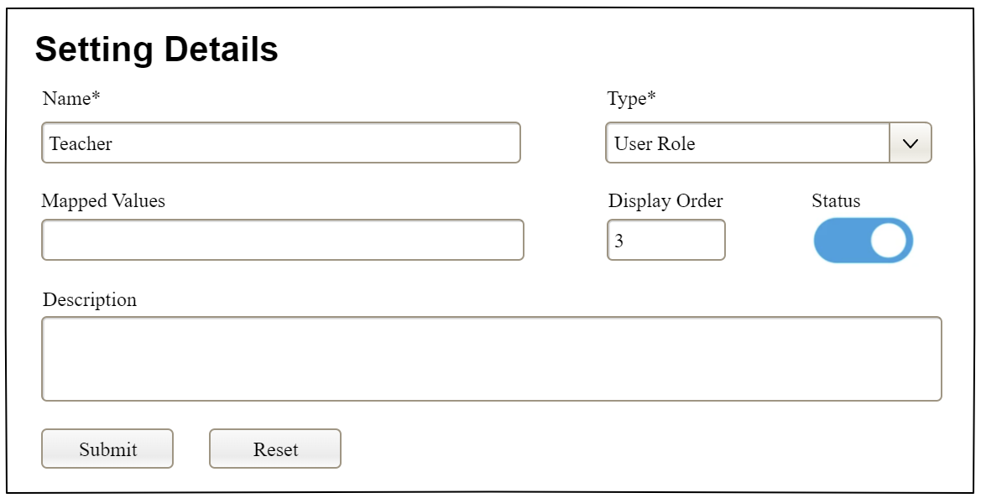

Field Name | Field Type | Description
Name* | Text Box  String (20) | Name of the setting
Type* | Combo Box  (Single Choice) | Type of the setting, filled with the list of setting types  Default value: the first type in the list
Mapped Values | Text Box  String (50) | Supplementary information for the setting (if any)
Order | Text Box  Integer (>=0) | Display order of the setting: the order of the setting type, displayed among the list of settings with the same type
Status | On/Off button | Status of the setting: Active or Inactive  Default value: Active
Description | Text Area  String (200) | Description of the setting
Submit | Button | Click to store new or updated setting details
Reset | Button | Click to reset the changes use has made on the screen fields back to the initial values when the screen is loaded

Database Access
…

IV. Appendix

1. Assumptions & Dependencies
[Record any assumptions that were made when conceiving the project and writing this vision and scope document. Note any major dependencies the project must rely upon for success, such as specific technologies, third-party vendors, development partners, or other business relationships.]
<<Sample:
AS-1: Systems with appropriate user interfaces will be available for cafeteria employees to process the expected volume of meals ordered.
AS-2: Cafeteria staff and vehicles will be available to deliver all meals for specified delivery time slots within 15 minutes of the requested delivery time.
DE-1: If a restaurant has its own on-line ordering system, the Cafeteria Ordering System must be able to communicate with it bi-directionally.
>>

2. Limitations & Exclusions
[Identify any product features or characteristics that a stakeholder might anticipate, but which are not planned to be included in the new product]

3. Business Rules
[Provide common business rules that you must follow. The information can be provided in the table format as the sample below]
<<Sample
ID | Category | Rule Definition
BR-01 | Constraints | Delivery time windows are 15 minutes, beginning on each quarter hour.
BR-02 | Constraints | Deliveries must be completed between 10:00 A.M. and 2:00 P.M. local time, inclusive.
BR-03 | Facts | All meals in a single order must be delivered to the same location.
BR-04 | Facts | All meals in a single order must be paid for by using the same payment method.
BR-11 | Constraints | If an order is to be delivered, the patron must pay by payroll deduction.
BR-12 | Computations | Order price is calculated as the sum of each food item price times the quantity of that food item ordered, plus applicable sales tax, plus a delivery charge if a meal is delivered outside the free delivery zone.
>>

4. ..

